Anexo I

MESH:

Entity | Size
Nodes | 4220
Elements | 13280

ELEMENT TYPE:

Connectivity | Statistics
TE4 | 13275 ( 99,96% )
SPIDER | 5 ( 0,04% )

ELEMENT QUALITY:

Criterion | Good | Poor | Bad | Worst | Average
Skewness | 9934 ( 74,83% ) | 3097 ( 23,33% ) | 244 ( 1,84% ) | 0,985 | 0,580
Stretch | 13193 ( 99,38% ) | 82 ( 0,62% ) | 0 ( 0,00% ) | 0,235 | 0,537
Min. Length | 13275 ( 100,00% ) | 0 ( 0,00% ) | 0 ( 0,00% ) | 0,488 | 3,544
Max. Length | 13275 ( 100,00% ) | 0 ( 0,00% ) | 0 ( 0,00% ) | 24,016 | 8,123
Shape Factor | 13135 ( 98,95% ) | 140 ( 1,05% ) | 0 ( 0,00% ) | 0,252 | 0,563
Length Ratio | 13249 ( 99,80% ) | 26 ( 0,20% ) | 0 ( 0,00% ) | 6,015 | 2,381

Properties.1

Material apply to
culata - OCTREE Tetrahedron Mesh.1 : culata

Material | G-AlSi12(Cu)
Young Modulus | 7e+010N_m2
Poisson Ratio | 0,346
Density | 2650kg_m3
Thermal Expansion | 0,00002
Yield Strength | 9,5e+007N_m2

Static Case

Boundary Conditions
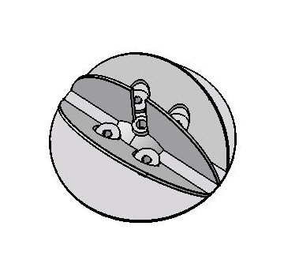

STRUCTURE Computation
Number of nodes | : | 4220
Number of elements | : | 13280
Number of D.O.F. | : | 13308
Number of Contact relations | : | 0
Number of Kinematic relations | : | 588
Number of coefficients | : | 2850

Linear tetrahedron | : | 13275
Smooth spider | : | 1
Rigid spider | : | 4

RESTRAINT Computation
Name: RestraintSet.1
Number of S.P.C : 792

LOAD Computation
Name: LoadSet.1
Applied load resultant :
Fx | = | -2 | . | 663e+005 | N
Fy | = | -1 | . | 158e+005 | N
Fz | = | -1 | . | 173e+005 | N
Mx | = | 1 | . | 181e+001 | Nxm
My | = | -5 | . | 668e+002 | Nxm
Mz | = | 6 | . | 793e+002 | Nxm

STIFFNESS Computation
Number of lines | : | 13308
Number of coefficients | : | 241392
Number of blocks | : | 1
Maximum number of coefficients per bloc | : | 241392
Total matrix size | : | 2 | . | 81 | Mb

SINGULARITY Computation
Restraint: RestraintSet.1
Number of local singularities | : | 0
Number of singularities in translation | : | 0
Number of singularities in rotation | : | 0
Generated constraint type | : | MPC

CONSTRAINT Computation
Restraint: RestraintSet.1
Number of constraints | : | 1380
Number of coefficients | : | 0
Number of factorized constraints | : | 1296
Number of coefficients | : | 0
Number of deferred constraints | : | 0

NUMBERING Computation
Restraint: RestraintSet.1
Numbering Method | : | SLOAN
Number of connected nodes | : | 4220
Nodal maximum front width | : | 202
Nodal maximum band width | : | 2386

Method | : | SPARSE
Number of factorized degrees | : | 12012
Number of supernodes | : | 1852
Number of overhead indices | : | 70923
Number of coefficients | : | 799170
Maximum front width | : | 342
Maximum front size | : | 58653
Size of the factorized matrix (Mb) | : | 6 | . | 09718
Number of blocks | : | 1
Number of Mflops for factorization | : | 9 | . | 322e+001
Number of Mflops for solve | : | 3 | . | 257e+000
Minimum relative pivot | : | 1 | . | 899e-003
Name: StaticSet.1
Restraint: RestraintSet.1
Load: LoadSet.1
Strain Energy : 6.983e+000 J
Equilibrium
Components | Applied  Forces | Reactions | Residual | Relative  Magnitude Error
Fx (N) | -2.6628e+005 | 2.6628e+005 | 5.2387e-010 | 2.0458e-014
Fy (N) | -1.1576e+005 | 1.1576e+005 | 4.3656e-011 | 1.7048e-015
Fz (N) | -1.1725e+005 | 1.1725e+005 | 7.2760e-011 | 2.8414e-015
Mx (Nxm) | 1.1813e+001 | -1.1813e+001 | -1.2887e-011 | 4.5961e-015
My (Nxm) | -5.6678e+002 | 5.6678e+002 | -4.5475e-013 | 1.6218e-016
Mz (Nxm) | 6.7934e+002 | -6.7934e+002 | 2.2965e-011 | 8.1901e-015

Static Case Solution.1 - Deformed Mesh
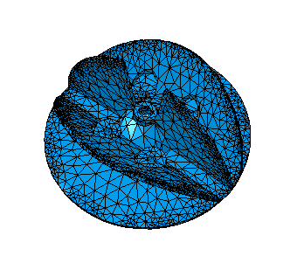
Display On Boundary ---- Over all the Model

Static Case Solution.1 - Von Mises Stress (nodal value)
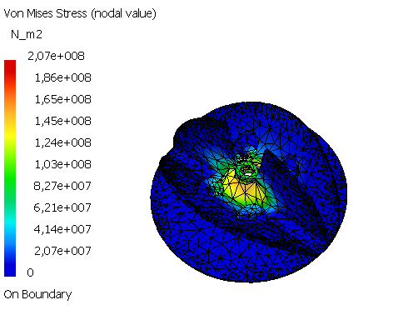
---- line Elements ---- : Components : ALL , Upper-Mid-Lower : Upper
---- Volume Elements ---- : Components : ALL
Display On Boundary ---- Over all the Model

Other Sensors

Sensor Name | Sensor Value
Energy | 6,983J

